Experiment - 09
Exploring AI-Assisted Features and Built-in Analytics (Zia) in Zoho Creator
SAI PRANAV B.V.
241401088 CSBS
AIM
To explore the built-in analytics, interactive dashboard charts, report display options, and availability of AI-assisted (Zia) features in the Patient Appointment & Scheduling Management application in Zoho Creator.
OBJECTIVE
- To observe the charts, and report access options available on the Appointment Dashboard.
- To identify the built-in display formats available for the appointment report.
- To check Design & Workflow areas of application editor for Zia or AI-assisted options.
SOFTWARE / TOOLS REQUIRED
- Zoho Creator
- Patient Appointment & Scheduling Management application
- Zoho account with access to the application and its editor
INTRODUCTION
AI-Assisted Features in Zoho Creator
AI-assisted features in a low-code application platform are intended to help users build applications and understand application data with less manual effort. Such features may assist with generating insights from stored data, answering questions about data, or suggesting application elements. The availability of these features depends on the Zoho Creator edition, account plan, and interface version.
Zia
Zia is the artificial-intelligence assistant of the Zoho ecosystem. Conceptually, Zia provides AI-driven capabilities such as data insights and assistance in working with application data within Zoho products. The availability and location of Zia features in Zoho Creator depend on the account and plan.
Built-in Analytics and Dashboards
Zoho Creator provides built-in analytics through pages and dashboards. A dashboard combines multiple components on one page so that application information can be understood at a glance. The Patient Appointment & Scheduling Management dashboard contains the following components:
- Appointment summary/KPI information.
- Department-wise appointment chart.
- Appointment status chart.
- Upcoming appointments information.
- Access to the complete appointment report.
Charts can visually represent application data, while reports present individual records in a structured format.
PROCEDURE
1. Open the Application
1. Open Zoho Creator and sign in.
2. Open the Patient Appointment & Scheduling Management application.
3. Select Access this application to open the live application.
2. Open the Appointment Dashboard
1. Open the Appointment Dashboard from the application navigation.
2. Observe the dashboard components.
3. Examine the appointment summary/KPI information.
4. Observe the department-wise appointment chart.
5. Observe the appointment status chart.
6. Examine the upcoming appointments section/table.
7. Observe the option to open the complete appointment report.
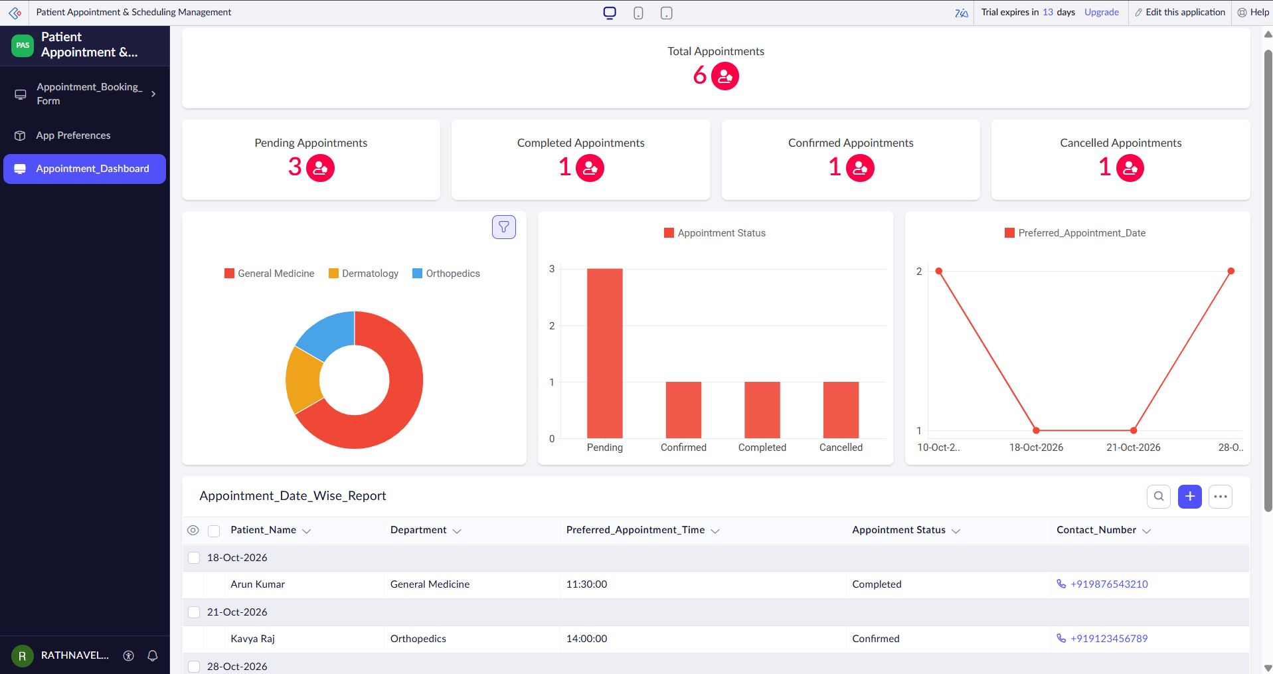
Screenshot 1 — Appointment Dashboard showing summary, charts, and upcoming appointments

3. Examine the Dashboard Charts
1. Examine the Department-wise Appointment chart.
2. Observe the number of appointments represented for each department.
3. Where interactive chart values are available, hover over the chart elements to read their exact values.
4. Examine the Appointment Status chart.
5. Observe the distribution of appointments among statuses such as Pending, Confirmed, Completed, and Cancelled.
6. Record the values displayed by the charts in the table below.
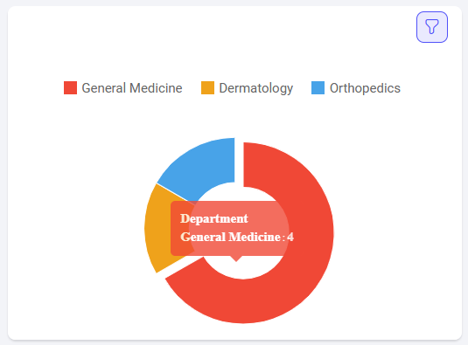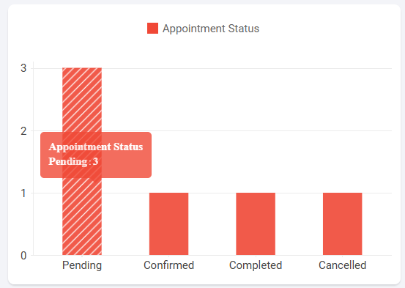
Screenshot 2 — Department-wise & Appointment status chart with exact values shown on hover

4. Open the Appointment Report
1. Select View All Appointments from the dashboard.
2. The appointment report opens and displays the records of the Appointment_Booking_Form.
3. Open the report options menu.
4. Select Show As.
5. Observe the report display formats available in the current interface.
6. Do not change or save the report view.
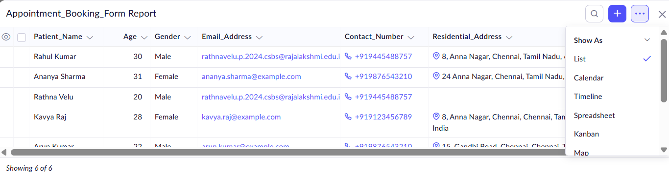
Screenshot 3 — Appointment report with Show As menu open, displaying the available report formats

5. Check the Design Area for Zia / AI Features
1. Return to the application editor.
2. Open the Design area.
3. Examine the available options.
4. Check whether any option specifically related to Zia, AI, AI-assisted features, or AI analytics is available.
5. Do not modify the application.
If no Zia/AI-specific option is visible, record that the feature was not available in the current account/interface.
6. Check the Workflow Area for Zia / AI Features
1. Open the Workflow section of the application editor.
2. Examine the available workflow and form-related options.
3. Check whether any Zia, AI, or AI analytics feature is available.
4. Do not create or modify any workflow.
5. Record the availability or non-availability of Zia/AI functionality.
OUTPUT
The Patient Appointment & Scheduling Management application dashboard was explored successfully. The following were examined:
- Appointment dashboard components.
- Department-wise appointment chart.
- Appointment status chart.
- Upcoming appointment information.
- Appointment report.
- Available Show As report-display formats.
- Design area for Zia/AI-assisted functionality.
- Workflow area for Zia/AI-assisted functionality.
The dashboard provides built-in analytics that help users understand appointment information without requiring external analytical tools.
Zia / AI-Assisted Feature Exploration
The application editor was checked for Zia/AI-assisted functionality. The Design area and Workflow section were examined for Zia, AI, or AI analytics options. If no such feature is visible in the current account/interface, the result is recorded as:
Zia / AI-assisted functionality was not available in the current account/interface. Zia was not used, configured, or demonstrated in this experiment.
Therefore, the practical work focuses on the built-in dashboard analytics, interactive charts, and report display options available in the application.
1. Design Area of the Application Editor
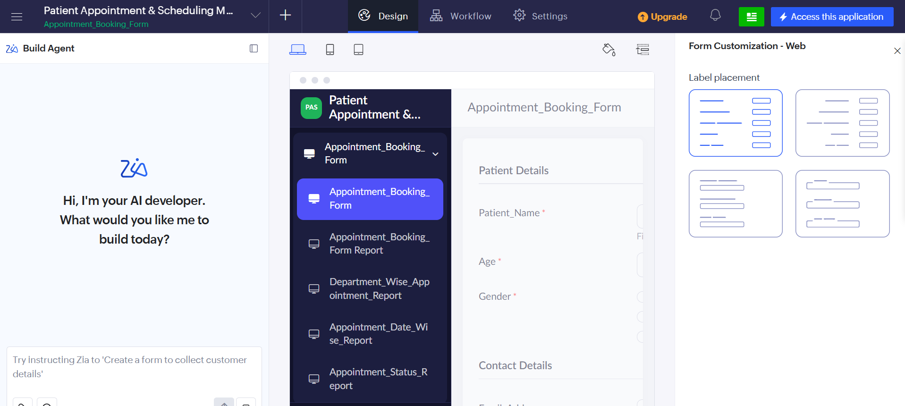
Screenshot 4 — Design area examined for Zia/AI-specific options

2. Workflow Section of the Application Editor
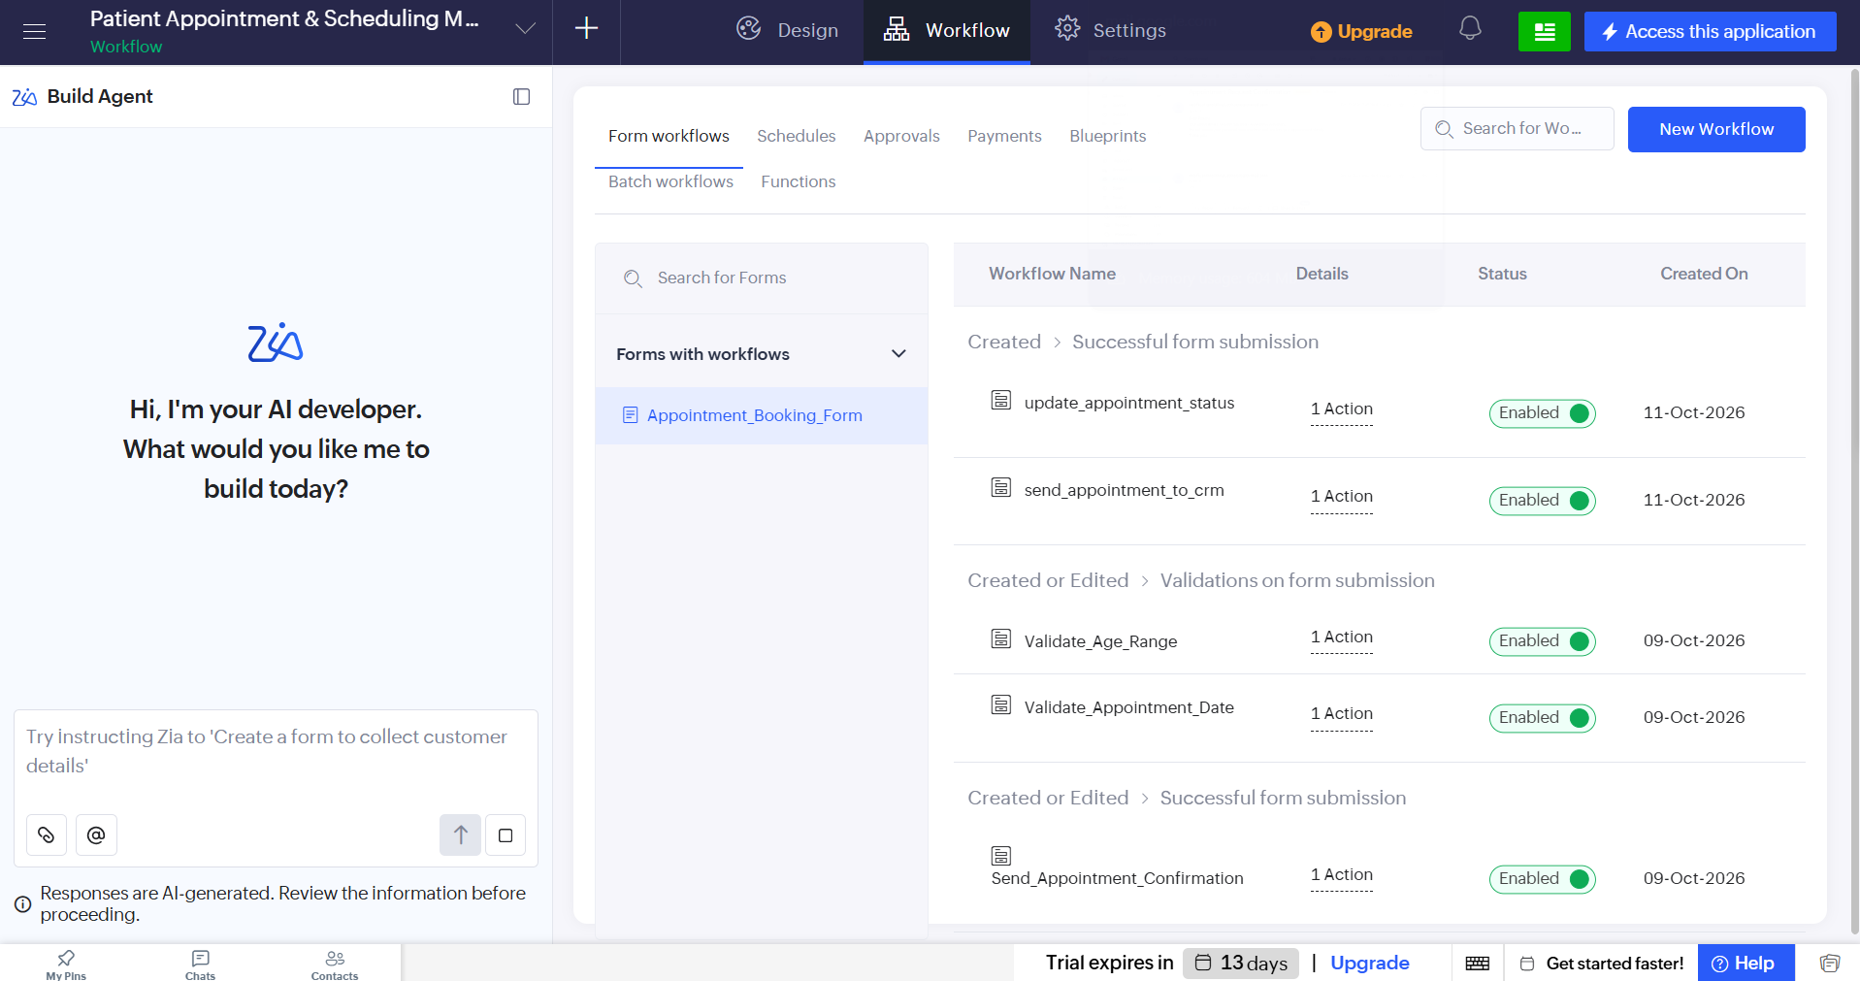
Screenshot 5 — Workflow section examined for Zia/AI-specific options

RESULT
The built-in analytics and reporting features of the Patient Appointment & Scheduling Management application were successfully explored. The dashboard charts and summary components were examined, appointment report display options were identified, and the Design and Workflow areas were checked for Zia/AI-assisted functionality. If Zia/AI functionality was not available in the current account/interface, it was not configured or demonstrated.

